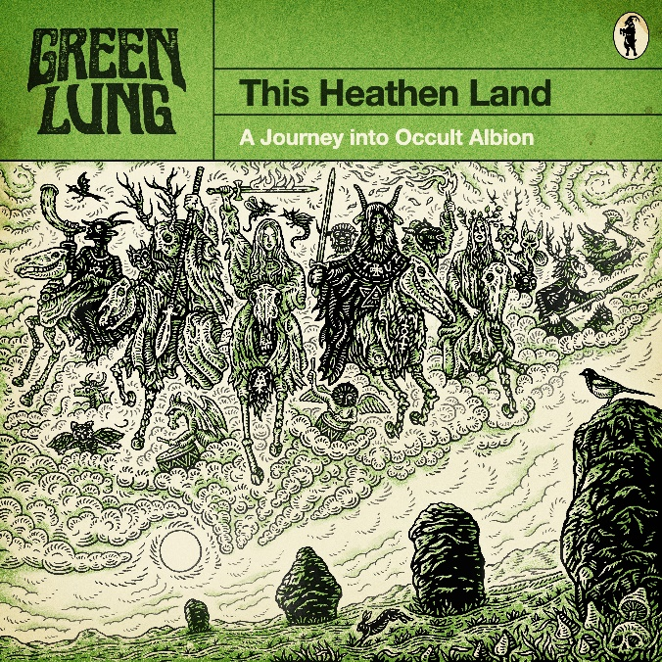

Green Lung
This Heathen Land

OUT: November 3rd 2023
Tom Templar | vocals  Scott Black | guitar  Joseph Ghast | bass  Matt Wiseman | drums  John Wright | organ | Greenlung.co.uk  Facebook.com/greenlungband  Twitter.com/greenlungband  Instagram.com/greenlungband

Beyond the cities and motorways of modern Britain, away from the influence of its Christian churches and cathedrals, lies another country. An older, stranger country. A country of lonely tors and desolate moors, of forgotten woods and mysterious standing stones. You are about to embark on a journey into occult Albion.

Come. It’s time to explore this heathen land…

GREEN LUNG are a cult band in every sense of the word. Formed in London in 2017, their first two records Woodland Rites (2019) and Black Harvest (2021) brought a folk horror sensibility to occult rock, attracting a fanatical following in their native UK and beyond, and resulting in international tours with the likes of Clutch, festival performances from Roadburn to Bloodstock to Download, and a record deal with the world’s biggest independent heavy metal label Nuclear Blast Records.

Now, two years after the release of the critically acclaimed Black Harvest, the band have unveiled their most ambitious offering yet. This Heathen Land is the most complete manifestation of the band’s vision to date, fulfilling their long-held goal to, in the words of vocalist Tom Templar, “create the definitive soundtrack to the folk horror film in our heads.”

On This Heathen Land, the band have forged a sound and identity that is entirely their own, while maintaining the Sabbathian heaviness and addictive songcraft which made their previous albums so beloved in the metal underground. From the cover art to the vinyl inserts and lyrical themes, This Heathen Land is a painstakingly-researched and executed heavy metal love letter to the folkloric landscape of the UK.
“Perhaps unsurprisingly, I’ve had the classic Reader’s Digest book Folklore, Myths and Legends of Britain by my bedside since childhood” says Templar. “With this album I wanted to conjure the experience of reading that book in sonic form - to take listeners on a journey into the weird world of British folklore, into the woods and over the mountains and onto the moors, and to inspire them to see the magic that’s still out there, if you use a little imagination.”

Working with producer/engineer Wayne Adams at Bear Bites Horse Studio once more, and now with Tom Dalgety (Opeth, Clutch, Ghost) on mixing duties, the band looked to classic albums produced by Martin Birch for sonic inspiration:

“There’s something very special about the records Birch produced in the late 70s and early 80s. Albums such as Sabbath’s Mob Rules and Rainbow’s Rising were made at a time before metal had become quite so codified; when it could still be eccentric and experimental, yet musical and accessible. With This Heathen Land, we wanted to make a record that pays homage to those classic records while adding a modern sensibility and musicality” says guitarist Scott Black.

This is reflected in the production of the record, which harks back to the maximalist bombast of Queen while maintaining a raw, authentic heaviness that reflects the band’s crushing live sound and Sabbathian roots. While the searing Hammond organs remain, the production also marks a development in the band’s sound-world:

“It was incredibly important to us that the sound of the album cohered with the imagery and themes, which is why we spent so long painstakingly recreating the sort of synthscapes that soundtracked the weird, haunting vintage TV documentaries that the album draws inspiration from” said Black.

The album is steeped in an atmosphere that evokes the BBC Radiophonic Workshop as well as synthesizer pioneers such as Wendy Carlos and the early works of bands like Goblin:

“These were soundtracks that were defined by their budgetary and technological limitations as much as anything,” continues Black. “Today, in a time of limitless instrumental VSTs, it was a refreshing creative challenge to have to think about arranging music for an assembly of (mostly broken) era-specific monosynths”

This Heathen Land is the sound GREEN LUNG have forged over their two previous records taken to its logical conclusion. This is reflected in the songwriting, with the album offering their most varied collection of songs yet:

‘The Forest Church’, inspired by the masterpiece of folk horror cinema Blood on Satan’s Claw, sees the band at their most sinister and brooding, before exploding into an anthemic chorus. Ascending into a whirlwind of triple tracked, intricately voice-lead guitar harmonies and a breathless, blistering organ solo, it immediately immerses the listener in the world of the album.

‘Mountain Throne’ is a galloping call-to-arms that showcases the band’s talent for writing hooky riffs and even hookier choruses. A paean to the victims of the Pendle witch trials, its pyrotechnic guitar work could raise the spirits of Demdike and Chattox themselves.

‘Maxine (Witch Queen)’, a love letter to the ‘witch queen’ of the Swinging Sixties, Maxine Sanders, is the band’s most danceable song yet. Pounding riffage melds with freakbeat combo organs and stacked, multi-layered vocal harmonies to establish one the most potent earworms on the album – the Green Lung equivalent of Type O Negative’s floor-filling psych-pop singles ‘My Girlfriend’s Girlfriend’ and ‘Be My Druidess’.

‘One for Sorrow’ is a unique beast, both sonically and musically. Weaving haunting synthscapes into crushingly heavy doom riffs and an epic chorus, it is GREEN LUNG at its heaviest and most devastating. Dancing around a number of tonal centres, it is one of the album's more progressive journeys, and features some of Templar’s most personal lyrics yet.

Since their inception, GREEN LUNG have woven folk and British root elements into their sound, and we hear this most fully realised in track 5, ‘Song of the Stones’, which is lyrically based on Grant Allen’s 1892 ghost story ‘Pallinghurst Barrow’. From its foreboding Lankum-esque verses, the song blossoms into a pastoral, beautifully harmonised chorus. Featuring a guitar solo that evokes Gilmour at his most psychedelic, it dissolves into a synth line that wouldn’t feel out of place in a Goblin soundtrack.

‘The Ancient Ways’ is a hymn to hiking that references several literary touchstones, from Alfred Watkins’s The Old Straight Track to Robert Holdstock’s Mythago Wood to the writings of John Muir. The song is heralded by a blaze of distorted organs and wailing guitars – GREEN LUNG at their most bombastic. Thudding, grooving riffs harken back to the band’s earlier material, before the song melts away into a hallucinogenic journey on a bed of mind-melting polyrhythms.

‘Hunters in the Sky’ is inspired by the current fight for the ‘right to roam’ on Dartmoor, and references the folklore of the region from Old Crockern to Wistman’s Wood. Wielding pummelling Matt Pike-esque riffs, an army of concussive war drums and the album’s heaviest breakdown, it’s the one of the most aggressive, rousing and cathartic songs the band have ever written.

Album closer ‘Oceans of Time’ takes its title from a line spoken in Bram Stoker’s Dracula, and is every bit as flamboyant and dramatic as the film that inspired it. From the swirling introductory synthscapes that evoke the wind howling across the Carpathian mountains to a wailing, emotive climax, ‘Oceans of Time’ sees the band at their most unapologetically musical, and takes their ‘vampire love song’ tradition established by ‘Graveyard Sun’ to dizzying new heights.

